DHANALAKSHMI SRINIVASAN AGRICULTURE COLLEGE
(Affiliated to Tamil Nadu Agricultural University, Coimbatore)
Perambalur -621 212
VISIT TO SEED TESTING LABORATORY, PERAMBALUR

The III Year B.Sc. (Hons.) Agriculture students underwent an exposure visit to the Seed Testing Laboratory, Perambalur on 25.06.2026 as part of the practical component of the course SST 351 Seed Entrepreneurship Skill Development and Management (1+1) offered during the VI Semester. A total of 40 students participated in the visit.
During the visit, Mrs. Ashalatha, Senior Agricultural Officer, Seed Testing Laboratory, Perambalur briefed the students on the objectives and functions of the Seed Testing Laboratory, the procedures involved in receiving different types of seed samples and the various quality tests carried out to ensure seed standards.
Subsequently, Mrs. Ambika, Agricultural Officer, Seed Testing Laboratory, Perambalur provided a practical demonstration on seed quality evaluation techniques including physical purity analysis, other distinguishable varieties (ODV) examination, moisture estimation, and germination testing. The students actively participated in the demonstrations and gained valuable hands-on experience in standard seed testing procedures.
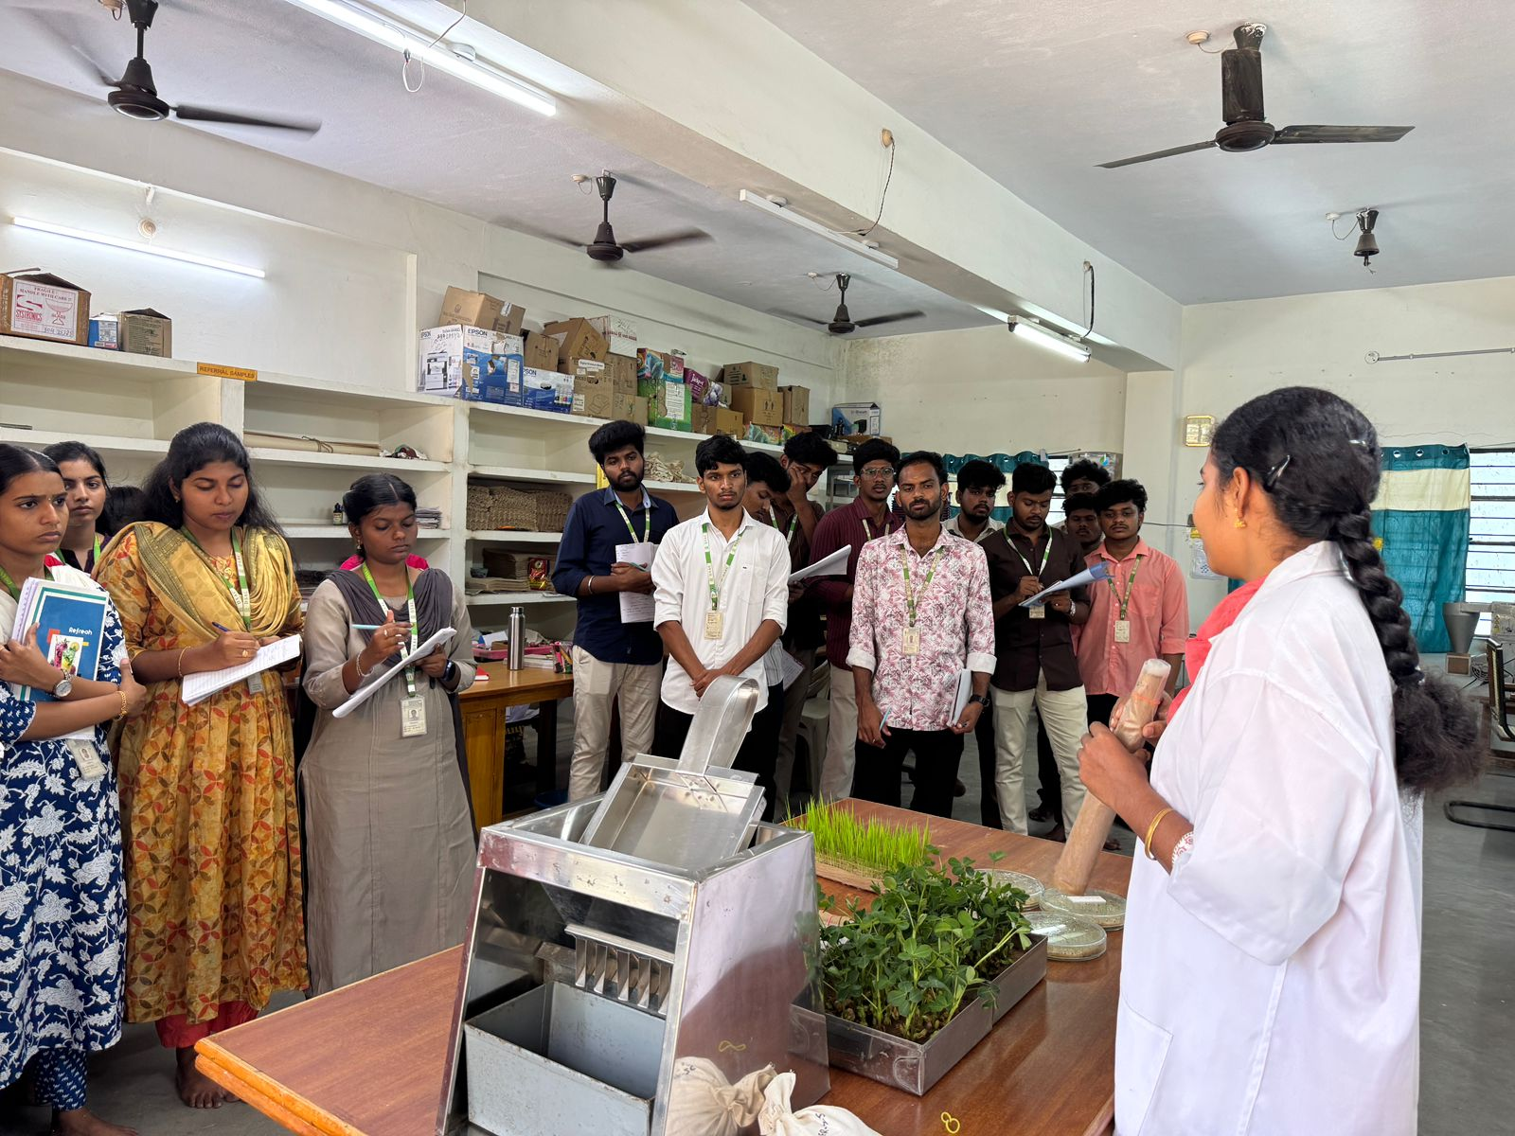
The exposure visit significantly enhanced the student’s practical knowledge and understanding of seed quality assessment, laboratory testing methods, and the importance of seed certification in ensuring the distribution of quality seeds to farmers.

